

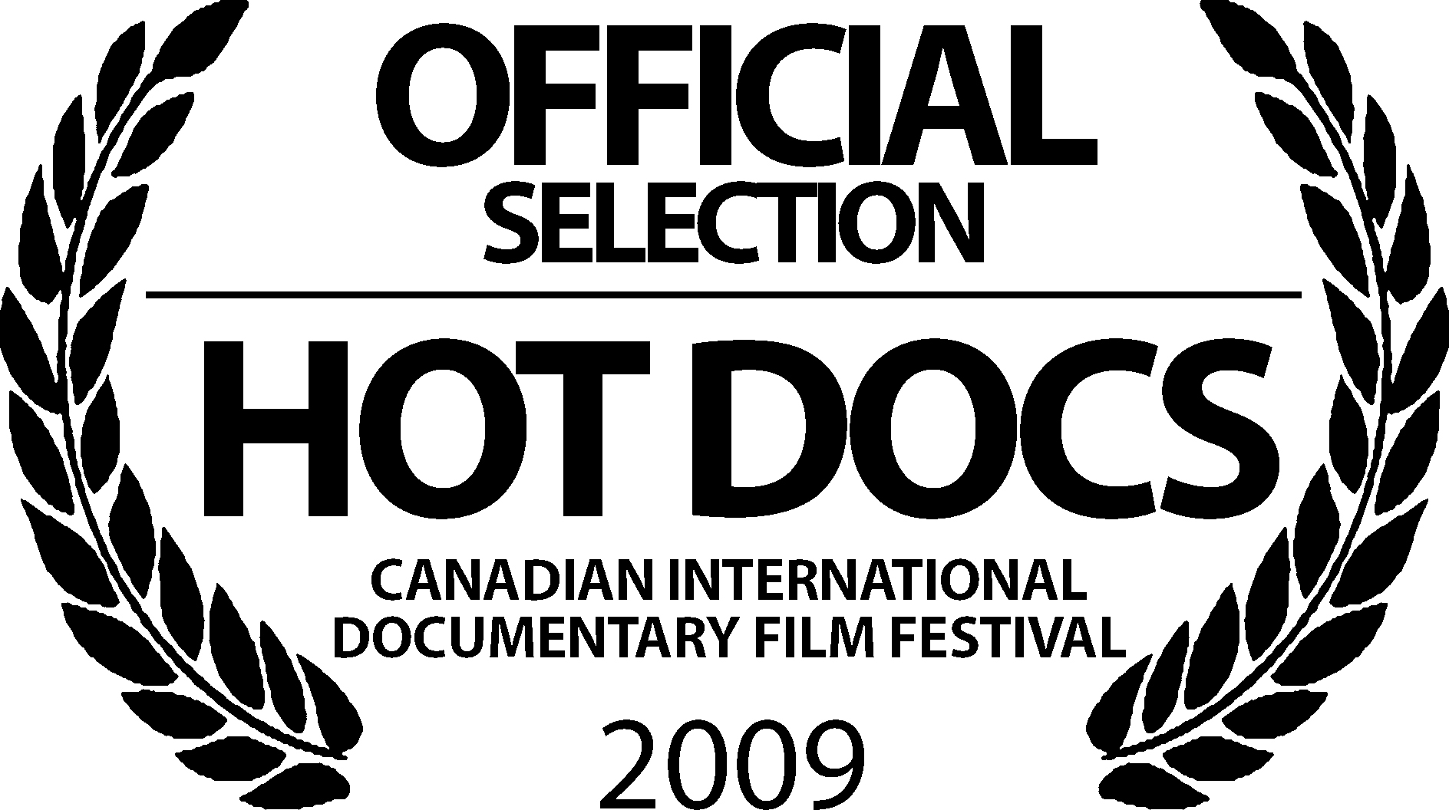

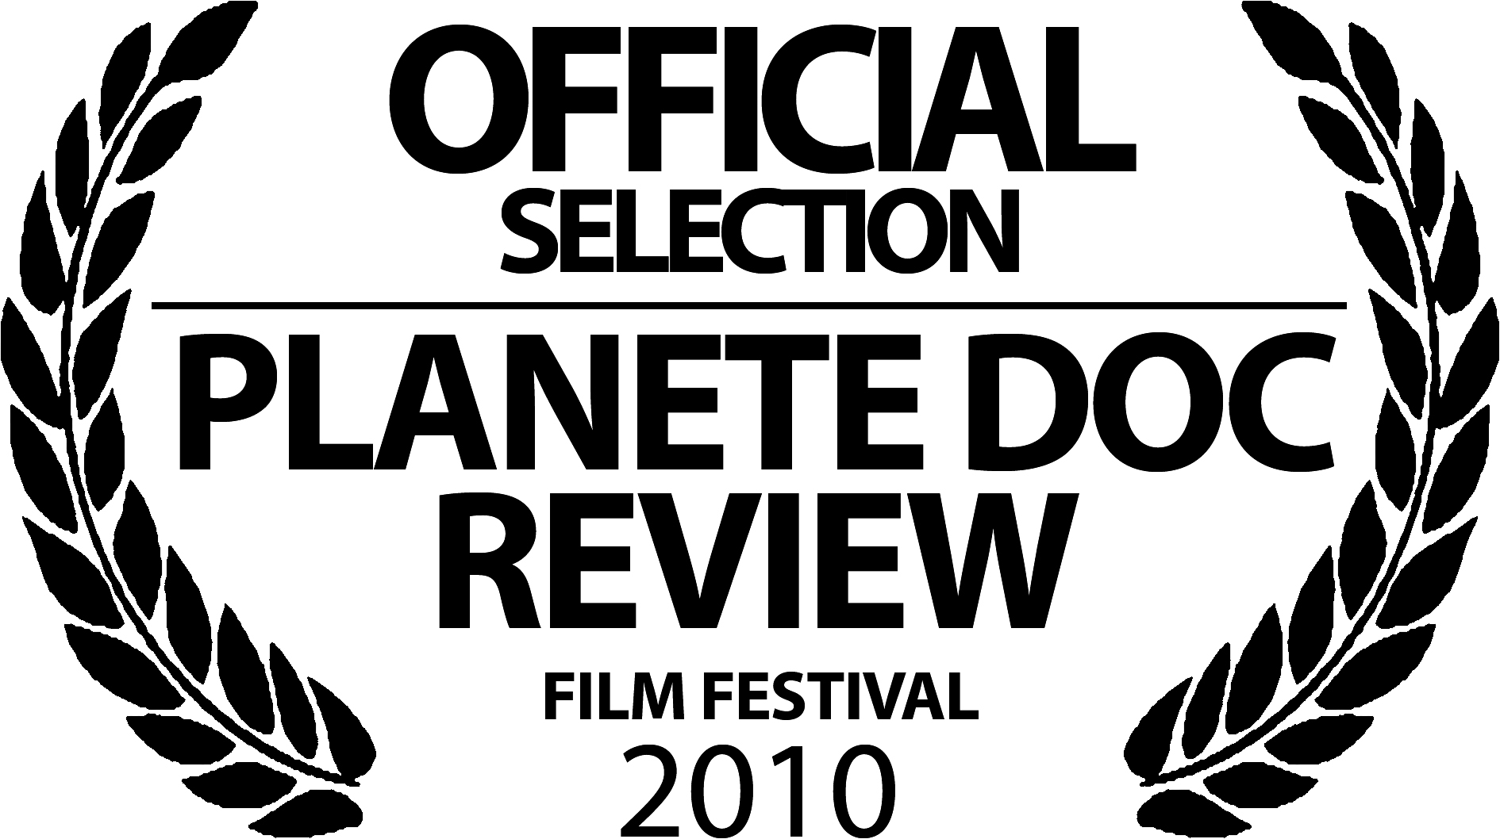

ORGASM INC.

Producer/ Director/Editor/Camera: Liz Canner
Executive Producers: Julie Parker Benello, Wendy Ettinger, Judith Helfand, Marc Weiss
Editors: Sandra Christie, Jeremiah Zagar Animation: Jay Beaudoin, Nicholas Fischer

(USA, September 2009, 78 minutes)
www.orgasminc.org

Contact: Liz Canner
Phone: (617) 733-8426
Email: lizcanner@astreamedia.org

"A sexy feature-length indictment of big pharma" that gives "a lot of great laughs."
-The Toronto Star
What Critics Say About ORGASM INC.

“Liz Canner ended up making a shocking but hilarious film, Orgasm Inc., which is causing a storm in America as it sets out to expose the drug companies and doctors who are now locked in a race to produce a 'female Viagra' - a treatment that promises women a super-charged sex life in a pill.”
-London Daily Mail

"Maintaining a playful tone, Canner's film nevertheless serves as an indictment of greed at the expense of women who have too long been kept in the dark about their own bodies and sexuality."
-indieWire

"Buzzworthy."
-Variety

“TV Tonight: Five Worth Watching”
-The Toronto Star

"Orgasm Inc. is a terrific new documentary that delves into designer vaginas and other true life tales of the commodification of women’s pleasure centers."
-JoAnn Wypijewski, The Nation Magazine

"Orgasm Inc. is one of the best documentaries on both sex and the medical field ever, witty, clever, informative and timely."
-Firedoglake.com

"Named one of 2009's Noteworthy Documentaries"
-Dox Magazine, European Documentary Network

"Orgasm Inc. hits female erogenous zones that pharmaceutical fixes can't find: your brain and your funny bone. "
- In These Times

"Named one of "Spring 2009’s Don’t Miss Documentaries"
-Rabble.Ca

"Orgasm Inc., a biting new documentary, gives a behind-the-scenes look at the race to develop drugs, devices, and surgery to treat female sexual problems."
- Vogue Magazine

“Upbeat, engaging, enlightening, and provocative, Orgasm Inc. will change the way you think about sex.”
-Hot Docs Film Festival

Logline
Extraordinary behind-the-scenes access reveals a drug company's fevered race to develop the first FDA-approved Viagra for women - and offers a humorous but sobering look inside the cash-fuelled pharmaceutical industry.

Synopsis
In the shocking and hilarious documentary Orgasm Inc., filmmaker Liz Canner takes a job editing erotic videos for a drug trial for a pharmaceutical company. Her employer is developing what they hope will be the first Viagra drug for women that wins FDA approval to treat a new disease: Female Sexual Dysfunction (FSD). Liz gains permission to film the company for her own documentary. Initially, she plans to create a movie about science and pleasure but she soon begins to suspect that her employer, along with a cadre of other medical companies, might be trying to take advantage of women (and potentially endanger their health) in pursuit of billion dollar profits. Orgasm Inc. is a powerful look inside the medical industry and the marketing campaigns that are literally and figuratively reshaping our everyday lives around health, illness, desire -- and that ultimate moment: orgasm.

Along with meeting drug company CEOs, field testers, and number crunchers, she encounters doctors, scientists and psychiatrists who are resisting the pharmaceutical industry's notion that sexual dissatisfaction is a "disease" that needs to be treated with a drug. Most of women's sexual problems, they believe, are due to cultural conditions -- relationship issues, sexual abuse, poor sex education, and stress from overwork. Their goal: stop corporate medicine before it is too late.

Throughout Orgasm Inc. important revelations are made and compelling characters are encountered who claim to hold the key to women's orgasm. We meet a doctor in Winston Salem, NC who is testing an Orgasmatron - electrodes inserted into the spine and activated at the press of a button. We encounter a medical device marketer, Lisa, who is deep in the process of launching Designer Laser Vaginal Rejuvenation surgery to "help" women look and feel young and tighter "down there". Ambivalent about the disturbing effects of cosmetic genital surgery, Lisa haltingly admits that she needs to quit her job on-camera. As Orgasm Inc. goes deeper, it reveals that many of the "treatments" for FSD have potentially dangerous and life-threatening side effects, including genital mutilation, breast cancer, and dementia.

Fortunately, all is not bleak on the sexual frontier, Liz also uncovers inspirational pioneers who are committed to leading others to true erotic fulfillment: a sex shop owner who crashes pharmaceutical conferences to educate the doctors who attend, a vintage vibrator collector who provides insight into the history of female "hysteria," and a professor whose monkeys have taught him to pay more attention to women. These visionaries believe that the key to sexual satisfaction is to change not just our sex lives but also our society.

As the film nears the finish line, Procter & Gamble pulls ahead of the other pharmaceutical companies. Its drug Intrinsa, a testosterone patch, touted to be the first drug to treat women with low sexual desire, goes before the FDA. At the heated hearing, activists face off against Procter & Gamble, battling not only over the drug’s FDA approval but ultimately our future cultural and scientific understanding of sex.

The world is beginning to be saturated with ads for sex treatments for women. The drug companies and medical device manufacturers have already begun spending millions of dollars on marketing not only their treatments but also the 'disease'. The existence of both 'disease' and 'cure' is beginning to dominate all discussion of sexual dissatisfaction, conveniently sweeping major contributing factors under the rug. Orgasm Inc. provides an antidote to drug company marketing and scientific distortion, and will help to protect women from being deceived into undergoing unnecessary and possibly unsafe medical treatments. Upbeat, engaging, enlightening, and provocative, Orgasm Inc. will change the way you think about sex.

Director’s Statement
After over a decade of producing documentaries on human rights issues such as genocide, police brutality, and world poverty, the violent images from my movies were giving me nightmares and making me depressed about the state of humanity. In order to change the script in my head, I decided my next project would be about pleasure, specifically, the science of female pleasure.

Then, strangely, while I was in the middle of shooting the movie, I was offered a job editing erotic videos for a pharmaceutical company that was developing an orgasm cream for women. The videos were to be watched by women during the clinical trial of their new drug. I accepted the job and gained permission to film my employers for my own documentary. I thought the experience would give me access to the secretive world of the pharmaceutical industry and insight into the latest scientific thinking about women and pleasure.

I did not set out to create an exposé, but what I uncovered at work compelled me to keep filming and investigating. This insider perspective allows the film to scrutinize the everyday patterns of pharmaceutical company work in order to explore a culture that has been perverted to place the drive for profit above our health. So much for pleasure…
Key Production Personnel Bios

Liz Canner, Director, Producer, Camera, Editor
Orgasm Inc. is award winning director Liz Canner’s first feature documentary. Even before it’s release, the documentary garnered attention and an award. Canner was recently named one of the top ten independent filmmakers to watch in 2009 by The Independent Magazine and honored with a Visionary Award from Dartmouth College for the movie.

Canner has created many innovative documentaries on human rights issues. Deadly Embrace: Nicaragua, The World Bank and the IMF, her film on the effects of IMF and World Bank policy was one of the first documentaries to look critically at globalization. It was used by over a thousand organizations worldwide as an organizing tool. Recently, Canner was honored with a prestigious Rockefeller Foundation Next Generation Leadership Fellowship for creating innovative media projects that strengthen democracy. She has also been the recipient of a Radcliffe Institute (Bunting) Film/Video Fellowship from Harvard University.

Since earning her BA with Honors in both Visual Arts and Anthropology from Brown University, Canner has received more than 40 awards, honors, and grants for her work. Her recent projects have been supported by foundations such as The National Endowment for the Arts and The Paul Robeson Fund for Independent Media. Her documentaries have been broadcast on television on PBS stations, cable, and internationally in many countries. They have screened at festivals like The New York Film Festival (Video Sidebar) at Lincoln Center and the Human Rights Watch Film Festival. She has shown her work at numerous museums and galleries including Boston's Institute of Contemporary Art, The Museum of Fine Arts, Boston, and the California Museum of Photography. She has served on the boards of directors of The Association of Independent Video and Filmmakers, the Boston Film and Video Foundation, White River Indie Films and Boston Cyberarts. She is the founder and director of Astrea Media, Inc., a nonprofit organization dedicated to creating inventive media projects on social issues.

Filmography:
Orgasm Inc. - 2009
Hidden Tribe - 2006
Bridges – 2004
Moving Visions - 2003
www.symphonyofacity.org - 2001
Deadly Embrace: Nicaragua, The World Bank and the IMF – 1996/1999
State of Emergency: Inside The Los Angeles Police Department – 1993
Hands on the Verdict: The 1992 Los Angeles Uprising - 1992

Executive Producers Bios

Julie Parker Benello
For the past ten years, Julie Parker Benello has produced documentaries on health and environmental issues for television. In 2002, Julie co-produced the Sundance award winning HBO documentary Blue Vinyl a film in search of the truth about vinyl (PVC), America's most popular plastic. Julie's commitment to linking filmmaking to environmental health started with her producing a one-hour documentary Prostate Cancer: A Journey of Hope which aired nationally on PBS in June 1999. In 2005, she founded Chicken and Egg Pictures -- an innovative film company, which provides grants and executive, produces select film projects.

Marc N. Weiss
Marc N. Weiss is probably best known as the creator and former Executive Producer of P.O.V., the award-winning public TV series showcasing independent documentaries. He has been involved in the production, distribution, and exhibition of independent media for more than 35 years. After several years as an independent filmmaker, in the mid-1970's he became a programming consultant to a dozen international film festivals. He created P.O.V. in 1988 and founded Web Lab – an online laboratory that develops innovative uses of the Internet to explore public issues -- in 1997. Marc is currently developing a fictional TV series that will use the Internet to engage its audience in unique ways.

Judith Helfand
Filmmaker, activist and educator Judith Helfand is best known for her ability to take heedless corporate behavior and make it personal, highly charged, and entertaining. Her films, The Uprising of 34 (Co-directed with George Stoney), Blue Vinyl (for which she and Co-Director Daniel Gold were nominated for two Emmy's), and its Peabody award winning prequel A Healthy Baby Girl (a five-year video-diary about her experience with DES related cancer), explore home, class, corporate accountability, intergenerational relationships and the ever shrinking border between what is personal and what is a critical part of the public record.

Wendy Ettinger
Wendy Ettinger is an award winning producer, director and casting director. Her first documentary, The War Room, directed by Chris Hegedus and D.A. Pennebaker was nominated for an Academy Award, won the D.W. Griffith for Best Documentary by the National Board of Review and the Audience Award at the Berlin Film Festival. Their second collaboration, Moon Over Broadway, was cited as Best Documentary of ’98 and aired on Bravo. Ms. Ettinger’s first feature film, Eye Of God, directed by Tim Blake Nelson, premiered at Sundance, and garnered the American Independent Award at the Seattle Film Festival as well as Tokyo’s Golden Bear Award and was recently re-released on DVD.

ORGASM INC. Production Credits

Director, Producer, Editor and Cinematographer
Liz Canner

Executive Producers:
Julie Parker Benello
Wendy Ettinger
Judith Helfand
Marc Weiss

Edited by:
Sandra Christie
Jeremiah Zagar

Original Score by:
Stephanie Olmanni
Alex Barnett
Don Glasgo

Consulting Producer:
Doug Block

Associate Producers:
Sarah Canner
Jane Applegate

Additional Editing:
Tricia Reidy
Becky Goldberg
Signe Taylor

Consulting Editor:
T Woody Richman

Animation:
Jay Beaudoin
Nicholas Fischer

Graphics:
Jay Beaudoin
Max Berger
Einat Gavish
Noel Villers

Researchers:
Piya Kashyap
Morgan Faust
Elizabeth Gibson
Glennis Gold

Sound Designer and Mixer:
Tom Paul

Sound Editor:
Erik Milano

Mixed at
The Cottage, Rockland County, NY

Online Editor:
John Fordham

Post-Production Services:

Frame Runner

Post Production Sound:
Gigantic Studios

Funders:
Chicken & Egg Fund
The Fledgling Fund
Moving Image Fund, LEF Foundation
Portrero Nuevo Fund
Puffin Foundation
Radcliffe Institute For Advanced Study, Harvard University
The Rockefeller Foundation Next Generation Leadership Fellowship

